SED & AWK
K Naveen Kumar
Introduction
In Linux and Unix, sed is a powerful command-line utility used for text processing and editing. The name sed stands for Stream Editor. It is mainly used to search, replace, insert, delete, and modify text in files automatically.
Unlike text editors, sed does not open the file interactively. Instead, it reads the file line by line, performs the specified operation, and prints the modified output.
Purpose of sed
The main purpose of sed is to perform automatic editing operations on text files or command output.
It is commonly used for:
- Replacing words or characters
- Deleting specific lines
- Printing particular lines
- Inserting or appending text
- Automating text modifications in scripts

Basic Syntax
- sed 'command' filename
- Example:
- sed 's/linux/unix/' file.txt
- This command replaces the word linux with unix in the output.
How sed Works
sed works in three main steps:
- Reads one line from the input file
- Applies the given command or operation
- Prints the modified line to the output
This process continues line by line until the entire file is processed.
Important sed Operations
1. Substitution (Replace Text)
The most common operation in sed is substitution.
Example:
sed 's/apple/orange/' fruits.txt
This replaces the first occurrence of apple with orange in each line.
To replace all occurrences in a line:
sed 's/apple/orange/g' fruits.txt
g means global replacement.
2. Delete Lines
sed can remove specific lines from a file.
Example:
sed '3d' file.txt
This deletes line number 3.
Delete multiple lines:
sed '2,5d' file.txt
This deletes lines 2 to 5.
3. Print Specific Lines
To print only certain lines:
sed -n '3p' file.txt
This prints only line number 3.

4. Insert Text
Insert text before a specific line:
sed '3i Hello' file.txt
Insert text after a line:
sed '3a Hello' file.txt

5. Edit File Permanently
By default, sed does not change the original file. To modify the file directly:
sed -i 's/old/new/g' file.txt
The -i option edits the file permanently.
Advantages of sed
- Fast and efficient for processing large files
- Useful for automation and shell scripting
- Works directly from the command line
- Can process data from pipes and other commands

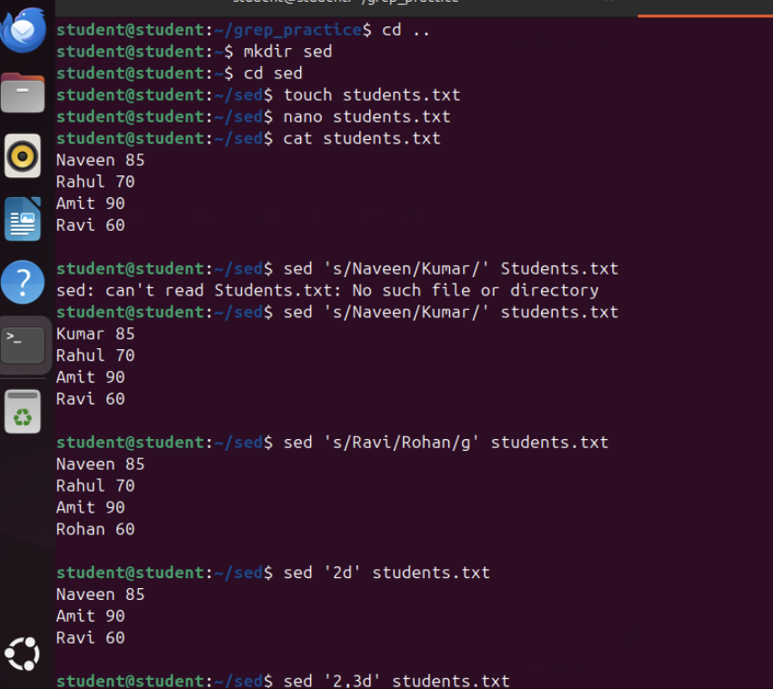



awk Command in Linux

Introduction
- In Linux and Unix, awk is a powerful command-line tool used for pattern scanning and text processing. It is mainly used to extract data, process columns, filter information, and perform calculations on text files.
- The name awk comes from the names of its creators: Alfred Aho, Peter Weinberger, and Brian Kernighan.
- awk is especially useful when working with structured data such as tables, logs, or CSV files.
Purpose of awk
The main purpose of awk is to process and analyze text files that are organized into rows and columns.
It is commonly used for:
- Extracting specific columns from a file
- Searching for patterns in text
- Performing arithmetic calculations
- Filtering data based on conditions
- Generating formatted reports
- Basic Syntax
- awk 'pattern {action}' filename
- Example:
- awk '{print $1}' file.txt
- This command prints the first column of each line in the file.
How awk Works
awk processes data in the following way:
- Reads the input file line by line
- Splits each line into fields (columns)
- Applies the specified pattern and action
- Prints the result
By default, fields are separated by spaces or tabs.
Important awk Concepts
Record
Each line in a file is called a record.
Example:
John 20
This entire line is one record.
Field
Each column or word in a line is called a field.
Example:
John 20
- $1 → first field (John)
- $2 → second field (20)
- $0 → entire line
Important awk Commands
1. Print Entire File
awk '{print}' file.txt
This prints all lines in the file.

2. Print Specific Column
awk '{print $1}' file.txt
This prints the first column.

3. Print Multiple Columns
awk '{print $1,$2}' file.txt
This prints the first and second columns.

4. Print Line Numbers
awk '{print NR,$0}' file.txt
- NR → line number
- $0 → entire line

5. Conditional Filtering
awk '$2 > 25' file.txt
This prints rows where the second column value is greater than 25.

6. Calculate Sum of a Column
Example file:
John 20
Ram 25
Sam 30
Command:
awk '{sum += $2} END {print sum}' file.txt
Output:
75
This calculates the sum of the second column.

Advantages of awk
- Efficient for processing structured text data
- Supports conditions and arithmetic operations
- Can generate formatted reports
- Useful for data extraction and analysis
